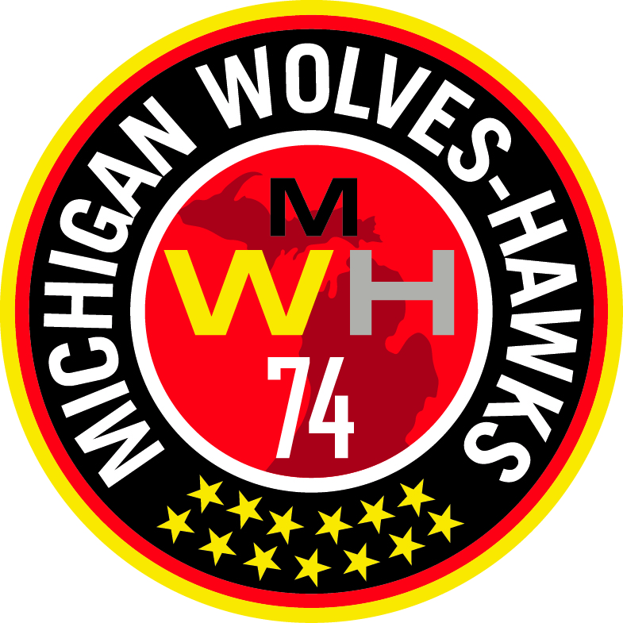 MICHIGAN WOLVES-HAWKS

Congratulations and welcome to the Michigan Wolves-Hawks Soccer Club! The following is the list of items that I will need from each of you. Please fill out all the forms and register using the Team Snap link before you leave today.

- MSDSL Player Contract completed & signed entirely. Must be turned in today!
- US Youth Soccer Medical Release Form.
- Copy of front and back of Health Insurance Card.
- Concussion Form
- Please try on all of the uniform pieces and record the sizes in Team Snap when you register.
- Copy of your child’s birth certificate.
- 1 small photo of your child (approx. 1.5” x 1.5” face shot) for pass card or update photo in Got Soccer.

Use the following URL link through Team Snap to register for the team. The link will include an electronic signature for:
- Parent or Guardian Consent to Travel Waiver.
- Registration Waiver & Disclaimer.
- Code of Conduct Waiver.
- Financial Commitment.
- Uniform sizing notice
- Complete the payment enrollment by credit card.

If you have any questions, please feel free to ask me. My contact information is:

Managers Name
Street Address
City, MI Zip
Home # (000) 000-0000
Cell # (000) 000-0000
Email address:

Thanks and I look forward to a great year together!

