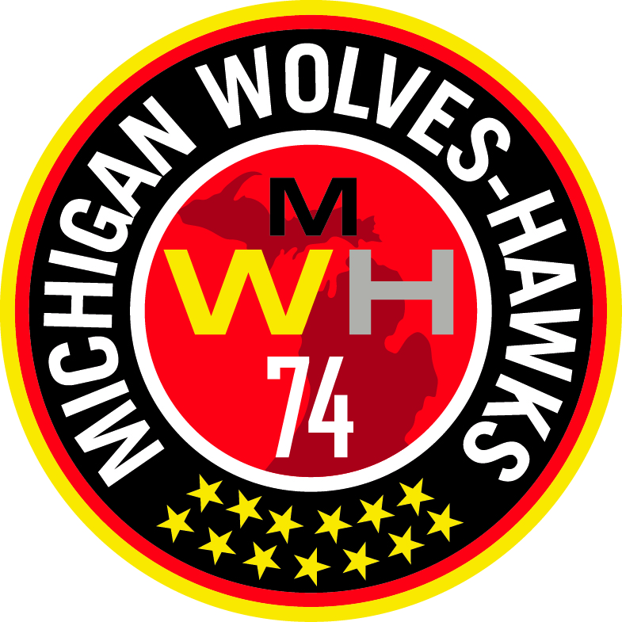 MICHIGAN WOLVES-HAWKS

Congratulations and welcome to the Michigan Wolves-Hawks Soccer Club! The following is the list of items that I will need from each of you. Please fill out all the forms and register using the Team Snap link before you leave today.

- ECNL Waiver
- US Club Registration Form
- Copy of front and back of Health Insurance Card.
- Concussion Form
- Please try on all of the uniform pieces and record the sizes in Team Snap when you register.
- Copy of your child’s birth certificate or passport.
- 1 digital photo of your child (approx. 1.5” x 1.5” face shot) for pass card.

Use the following URL link through Team Snap to register for the team. The link will include an electronic signature for:
- Parent or Guardian Consent to Travel Waiver.
- Registration Waiver & Disclaimer.
- Code of Conduct Waiver.
- Financial Commitment.
- Uniform sizing notice
- Complete the payment enrollment by credit card.

If you have any questions, please feel free to ask me. My contact information is:

Managers Name
Street Address
City, MI Zip
Cell # (000) 000-0000
Email address:

Thanks and I look forward to a great year together!

